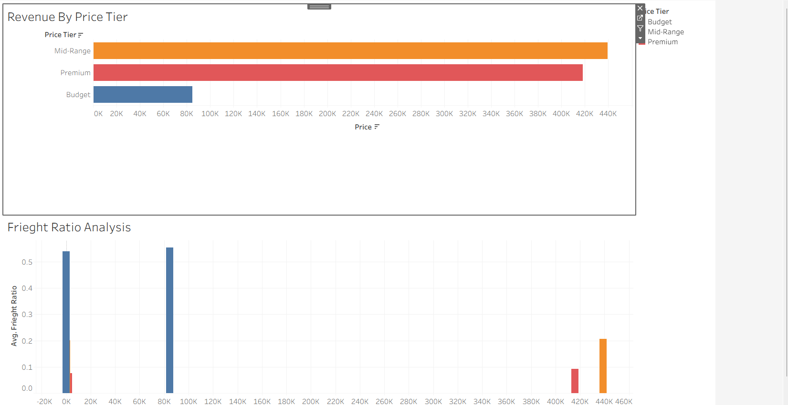
Fig 1: Revenue Performance Dashboard
This dashboard tells the story of how the e-commerce platform generates revenue over time and how customer purchasing behaviour influences overall sales performance.
The Monthly Revenue vs Order Volume graph shows that revenue and order volume follow a similar trend, indicating that revenue growth is largely driven by the number of orders placed. During certain periods, particularly towards the end of the year, there is a noticeable increase in both revenue and order volume. This suggests the presence of seasonal demand, likely influenced by major shopping events such as Black Friday and holiday sales.
The Revenue by Price Tier graph reveals that mid-range products contribute the highest portion of total revenue. This indicates that customers prefer products that offer a balance between affordability and quality, rather than extremely cheap or premium-priced items.
Overall, this dashboard shows that seasonal demand and pricing strategy play a key role in revenue generation, and businesses can maximize revenue by focusing on mid-range products during high-demand periods.

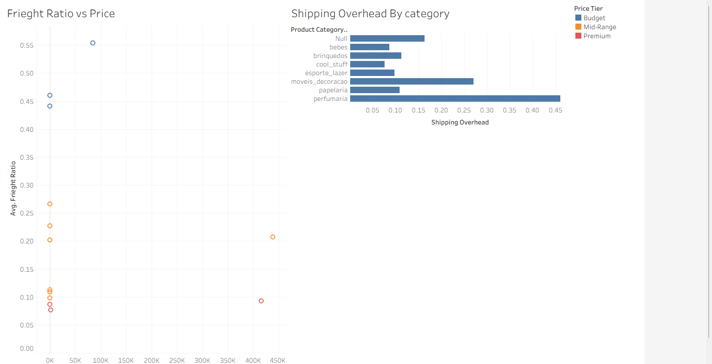
Fig 2: Operational Overhead Dashboard
This dashboard highlights how logistics and shipping costs impact product profitability and operational efficiency.
The Freight Ratio vs Price scatter plot shows that lower-priced products tend to have higher freight ratios, meaning that shipping costs form a larger portion of the product price. This can reduce profitability for budget products. On the other hand, premium products have lower freight ratios, indicating more efficient cost distribution.
The Shipping Overhead by Category graph shows that certain product categories incur significantly higher shipping costs compared to others. This variation may be due to differences in product size, weight, or delivery distance.
The overall story here is that logistics costs are not uniform across products, and certain categories may require pricing adjustments or optimized shipping strategies to maintain profitability.

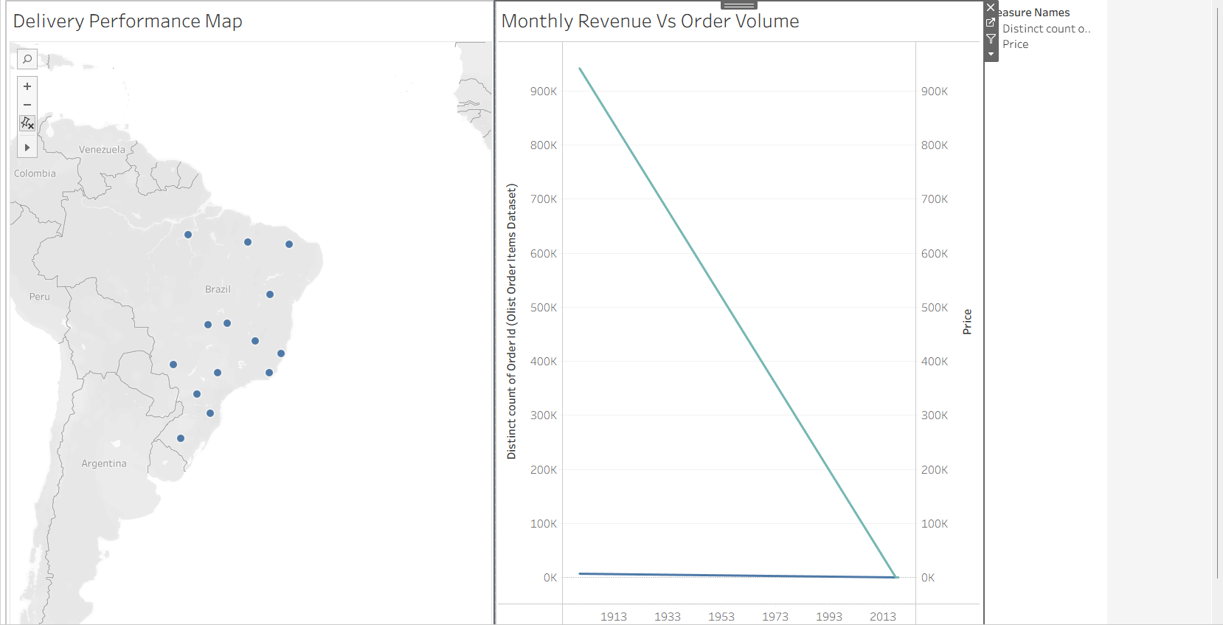
Fig 3: Fulfillment Quality Dashboard
This dashboard represents how efficiently the e-commerce platform fulfills customer orders in terms of delivery performance and order trends over time.
The Delivery Performance Map on the left visualizes the geographical distribution of delivered orders across Brazil. Each point on the map represents a region where orders have been successfully delivered. The higher concentration of points in certain areas indicates regions with strong customer demand and well-established delivery networks. These regions can be identified as key operational zones where the logistics system is functioning effectively. On the other hand, areas with fewer delivery points may indicate either lower demand or potential gaps in delivery coverage, suggesting opportunities for expansion.
The Monthly Revenue vs Order Volume graph on the right highlights the relationship between the number of orders and the revenue generated over time. The trend shows that as order volume increases, revenue also increases proportionally, indicating a strong dependency of revenue on order fulfillment. Any fluctuations or decline in this trend may indicate seasonal effects, operational delays, or reduced customer demand.
Overall, this dashboard tells the story that efficient fulfillment directly impacts revenue generation and customer satisfaction. Regions with strong delivery performance contribute significantly to business success, while improving logistics in weaker regions can further enhance overall performance.

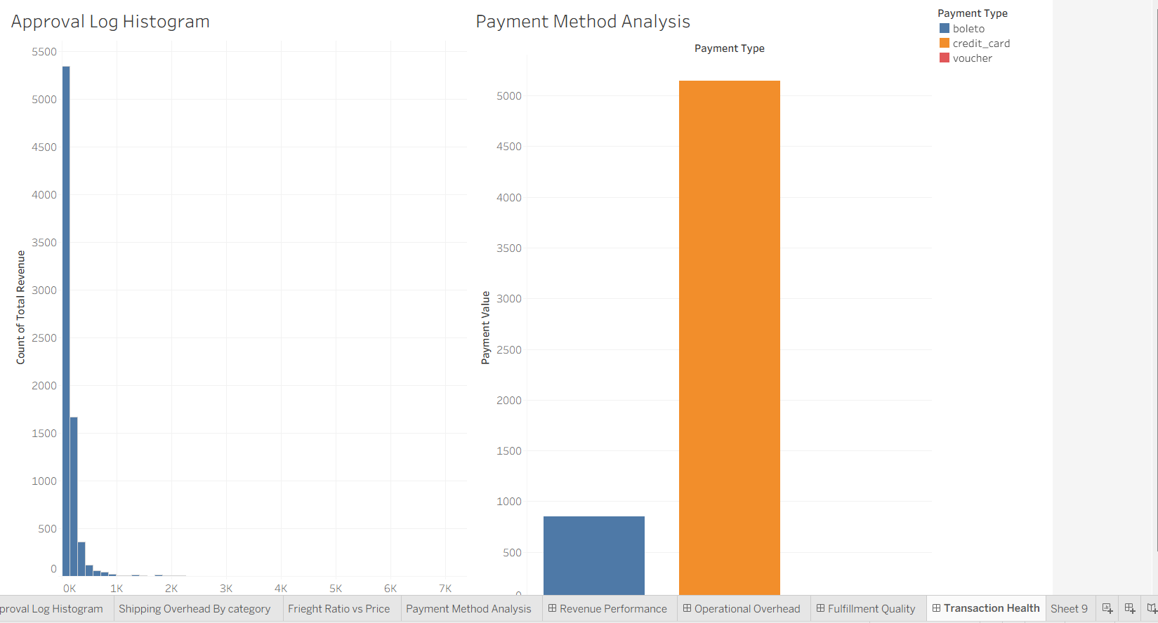
Fig 4: Transaction health Dashboard
This dashboard focuses on evaluating the efficiency and reliability of the transaction process, covering both order approval time and customer payment behavior.
The Approval Log Histogram on the left shows the distribution of time taken for order approvals. The graph is highly concentrated near the lower values, indicating that the majority of orders are approved very quickly. This reflects an efficient order processing system where most transactions are completed without delay. However, the presence of a few bars extending towards higher values indicates that some orders take significantly longer to get approved. These delays could be due to payment verification issues, system bottlenecks, or operational inefficiencies. Although these cases are fewer, they can negatively impact customer experience.
The Payment Method Analysis graph on the right highlights customer preferences in payment options. It clearly shows that credit cards dominate the transaction value, contributing the highest share of total payments. In comparison, other methods like boleto and vouchers contribute significantly less. This indicates that customers prefer fast, secure, and convenient digital payment methods.
Overall, this dashboard tells the story that while the transaction system is generally efficient and smooth, customer experience is heavily influenced by fast approvals and preferred payment methods. Improving slower approval cases and supporting dominant payment modes can further enhance transaction success and customer satisfaction.

